Spain: Growth Without Abundance (Where to Find It)
If we’re growing so much, where’s your share, which isn’t
July 1, 2025



U5
12
22
Com
Imagine a couple. Let’s say they’re almost 35. They studied one of the typical majors. They moved to Barcelona from their hometown, which is somewhere else in Spain, Europe, or Latin America. They don’t exactly work in their field, but it’s not like “their field” was exactly in high demand either. They earn more than those who stayed in that city, but that doesn’t mean they’re better off. They rent, while others have bought homes. Whenever they watch the news, they’re told that Spain is growing faster than Germany, France, or the Eurozone in general. It’s been like this for two or three years, since the end of the pandemic. They aren’t economists, but they don’t need to be to see that this doesn’t match what they experience in their day-to-day lives. They aren’t better off than they were a few years ago. In fact, things clearly aren’t going the way they expected when they started their adult lives, ten or twelve years ago.
They aren’t economists, let’s say. But they do sense that inflation has something to do with it. They’ve seen it right before their eyes: the rising prices of groceries at the supermarket… not to mention housing.
But is that all there is to it? Isn't there something else? There must be, because after all, those growth figures usually account for inflation, don't they?
What else is there? Where is that growth? Why aren’t you seeing it?

We’re growing (mostly) because there are more of us
Let’s start with a simple chart: how much Spain has grown over the decades. But let’s do this by comparing the total growth in our economy’s output (GDP: what we produce or spend each year) with the share of that growth per capita (GDP per capita), adjusted for inflation.
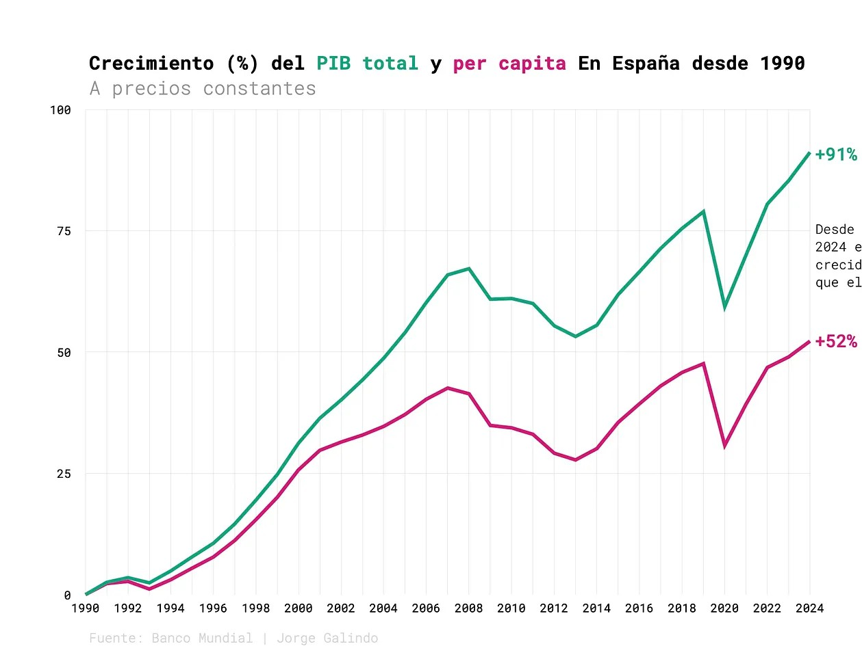

Between 1990 and 2024, Spain’s real GDP has nearly doubled, but GDP per capita has only increased by about half (+52%). The bulk of aggregate growth stems from an increase in the labor force—primarily due to the net inflow of migrants and the greater participation of women, older adults, and other demographics—rather than from improved output.

per resident. The social (and ultimately political) implications are that while Spain’s economy has grown, household incomes have not kept pace.
Someone might think: well, this must be true for most of our surroundings, right? And it is, but not to the same extent. Spain is the fourth EU country with the largest gap between GDP per capita growth and total GDP growth.

My dear and admired Manuel Hidalgo, one of the best economic analysts in this country, reacted to this chart by sending me a WhatsApp message: “an indirect way of calculating productivity.” It’s imperfect: because here I’m not considering the result per hour worked or per employed person. But I insist that what interests me is both the macro trend (which isn’t so bad: productivity per

It’s not just about overall growth (even though we’re far behind our neighbors), but about the impact on the grassroots level. Because when we keep saying that Spain has been growing well above the European average this decade—and has continued to do so in recent years—we’re talking about total GDP. It’s no wonder the average working-age citizen keeps asking: “Where’s my share?”
With these figures, we have the second part of the answer: this GDP growth is primarily because there are more of us working, not so much because each of us is producing more. In fact, if we look at the trend over the last two years—specifically that latest post-pandemic surge—the overall growth rate is even steeper.
Thus, inflation and population-labor force expansion account for part of the growth. But that’s not the end of the story.

The rest of the growth goes to the wealthy
We still have per capita growth, adjusted for inflation. Why does the average person feel like they aren’t seeing it? Could it be that incomes have shifted toward the wealthy? Not necessarily. Spain’s top 1% of earners are below the European average, and the top 10% are actually below this average, according to estimates from the World Inequality Lab.

However, what happens if we look at average income (now from another source, the Living Conditions Survey) by age group? Well, over the last two decades, only one group has actually seen growth: older adults. It is particularly striking how the gap between them and those under 30 is widening. Those aged 30 to 44—the age group our hypothetical couple falls into—are faring much better. A series of U-shaped curves that have not managed to recover to the point where the crisis left us.

Consequently, real spending (adjusted for inflation) has fallen across all groups, except for those aged 65 and older. And the difference with those under 30 is striking, to say the least, as Jon González showed in one of my recent favorites.

All of this already resonates with the experience of the hypothetical couple in the
right? Stagnant or slowly rising incomes. Only now are people earning what those of the same age were earning a decade and a half ago (and that was a good barometer of expectations: because back then, in their adult lives), while spending is on the decline. Let’s say the new generations have followed a U-shaped curve. Our couple’s expectations were at the start of the curve, on the far left. And they are still completing their arduous climb to the far right.
Although not everyone is in this situation, or not everyone to the same extent. The annual wage growth for workers in the public administration sector has been much more moderate. In fact, comparing 2008 and 2022, it turns out that this group’s earnings have risen slightly, while those of the rest have remained flat or fallen since 2008. The gap between the two, which already existed, has widened. In short, if someone has stayed in a small-to-medium-sized city in Spain and is also a civil servant, it’s clear that, relatively speaking, they are better off.

Furthermore, public sector workers with a college degree earn more than their private sector counterparts. In other words, this gap is not due to differences in education. To sum up: clearly, pensions and housing income have risen more. These support older groups, who are either retired or own a home. All of this helps explain why the trend is much more pronounced for our couple in their late 30s, leading them to consider whether it might be better to take a civil service exam. Because while they can retire, buying a home to rent out is even less of an option.

The Misguided Progressive Response

For all of the above to happen, the distribution of our spending has had to change. We tend to look at where the money has gone, but let me focus on the areas that have lost the most: public infrastructure.

The money for pensions comes, of course, from increasing pressure on labor.

Yes: this is happening because the population is aging, because we have generations retiring with better careers than their predecessors, and because we’ve once again tied pensions to the CPI. I understand these factors, but that’s not really my point here: my point, as I said at the beginning, is to explain the sense of scarcity and stagnation that any of us might feel, even in a context of growth.
Thus, public spending does not pull the country or its productive classes out of the current slump: it is not increasingly investing in education, R&D, or infrastructure that supports efficiency (such as energy or transportation). Nor is it investing in specific goods in high demand, such as housing
On the contrary, it adds pressure to labor incomes that are already struggling to keep pace.

It is true that, to counteract this inertia and address the sense of scarcity and stagnation, our leaders have relied almost entirely on three types of policies:
- Increasing income by law. Especially the minimum wage (though we could also include here the intention to reduce labor costs while maintaining wages). I will not delve into the results of these policies, but I will draw attention to the fact that the only way we have managed to improve the meager incomes of the working class is through decree.
- Subsidizing the demand for basic goods. Discounts on public transit, rental subsidies for young people, tax breaks on basic foodstuffs or fuel. Aside from the many problems these measures have, in the context at hand, they are a bit like playing solitaire with a cheat. “I’ll subsidize your prices since I’m not increasing your income” does not seem like a sustainable approach in the long term.
- Regulating the housing shortage, especially in the most basic housing sector. Determining who can access the limited supply and at what price (let’s not forget that this idea of regulating access has been attempted in other areas, such as controlling food prices). At best, this reorganizes the distribution of crumbs, but does not address the problem. And, at worst (unfortunately, more commonly), it exacerbates the problem. See rent control: it undoubtedly benefits those who already have a lease (prices go down), but it systematically harms those seeking to enter the market, reducing available supply and raising barriers to entry.
Let's get back to our couple. Over the past few years, their wages have gone up in nominal terms—they don't earn the minimum wage (not even close)—but their pay is tied to it through a

collective bargaining agreement. The truth is, it hasn’t helped them much given how much groceries, electricity bills, and gas have gone up. Transportation is much cheaper, OK, but it just so happens that they depend on the Rodalies system (Renfe commuter trains) to get to their respective jobs, and their problem has never been the price, but rather the irregularity of the service. They aren’t eligible for the rental subsidy because they earn more than the limit, but the truth is that their fear isn’t so much the price of their current apartment as the fact that their lease expires in a year: they’ve seen how incredibly difficult it is to find an available apartment in the city, even with the subsidy. Since rent control was implemented, it seems there are only monthly options, and even those aren’t plentiful. Simply put, there isn’t enough supply, and what does come onto the market gets snapped up too quickly. They would receive assistance and decide to have a child (they’re thinking about it); but, aside from the fact that this would mean paying for household goods that keep rising in price, what worries them most is having to look for a bigger apartment when there are hardly any available, or finding a spot in early childhood education: for the past three years, public schools have been free in Catalonia, but it turns out that this has increased demand even more and made the competition fiercer.
It feels a bit like being on a treadmill: the speed keeps increasing, but you’re always in the same spot. Then you look back and see that there are many others getting on that same treadmill. On either side, others are moving without a treadmill, more slowly, but they’re making progress: those who stayed in their hometown, those with civil service jobs, or your own parents, who paid into the system their whole lives and have their rent covered. But you’re still on

How to Really Make Progress
Honestly, I don’t know when we decided that progress meant creating scarcity instead of fighting it. You can spread the problem of scarcity

money, but if the supply can't keep up with the demand (prices will actually tend to absorb a good chunk of it), you're still stuck on the treadmill. It seems like you're making progress, but you're not. In the end, there's nothing. Treadmill.
For me, progress is something else: it is more than that, and the more people who benefit from it, the better. Progress is abundance that is shared and accessible. The book arguing this for the U.S. has already been written, and it is the one that has guided this line of reasoning, leading to a concrete proposal: let’s redirect public action toward creation. We can and must maintain monetary stimulus policies that have proven to work well (e.g., educational grants and minimum income systems, albeit much better designed). In the medium term, the focus lies elsewhere:
- Unlock the solution that will help you solve your problems. Didn’t Luis Garicano say the other day that any new regulation (or, I might add, the reconsideration of any existing regulation) should follow a certain
Will this help us have more housing? Well, I would apply this criterion to everything where we have bottlenecks. Affordable energy, smooth transportation, computing capacity, competitive research at our universities, basic educational offerings… the regulations that establish the framework for all of this—once a reasonable minimum of security is guaranteed—do they help or hinder?
- Build what is needed and what the private sector is not willing or able to do. Increase the proportion of public spending allocated to knowledge and human capital (early childhood education centers or research); ensure equitable access that promotes equal opportunities to contribute to and benefit from growth (housing and residences); increase efficiency and productivity (better

—especially local ones—; and protect existing capabilities to ensure the continuity of the system.
- Above all, shift public resources toward the early stages. Every euro (note: well-spent) invested in early childhood education (ages 0–3), academic support, work-life balance mechanisms, or research yields a multiple return in future productivity and greater equality of opportunity, taking advantage of the fact that we will likely have additional funds available due to lower costs in the education system.
All of this not only unlocks supply and makes it better suited to demand but also serves as a lever to boost economic productivity while expanding equal opportunities. In the energy sector, this may seem more obvious, but it’s equally true elsewhere: if people can live where they want because that’s where opportunities arise and they can contribute to the economy, the allocation of labor to companies or of human capital to those seeking to acquire it through education becomes more fluid. With productivity, real wages rise—not by decree, but because companies compete for talent that can now live, move, and train more effectively. When the economy turns, income grows faster than rent or electricity bills.
And if you’re also concerned about how the government spends the money it collects, that’s precisely the conversation we need to have. Every public euro allocated to expanding supply—in housing, energy, knowledge, infrastructure—is a euro that multiplies material possibilities for everyone, not one that simply reorganizes who has access to the little that is available. We can (and must!) frame the ideological debate not as a choice between those who want more or less government, but between those who resign themselves to using it to manage scarcity and those who aspire to foster shared prosperity.

